Conventional signs (refer bk. 5,6,8) \

Grid references
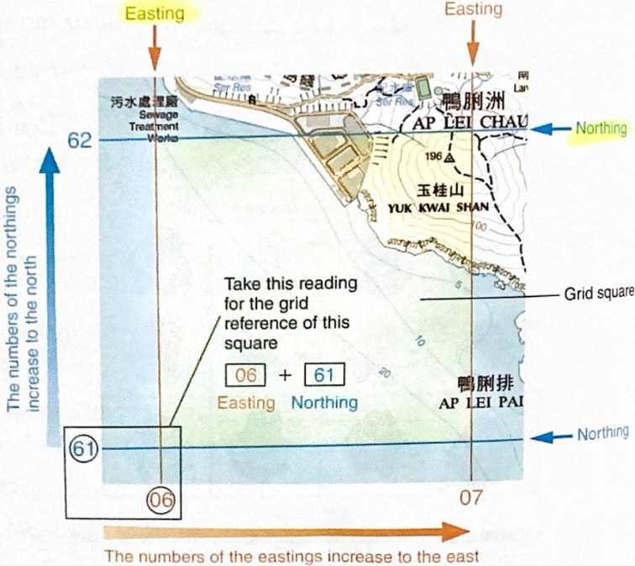
We locate object by using four-figure grid reference : combine easting and northing
And six figure grid reference :
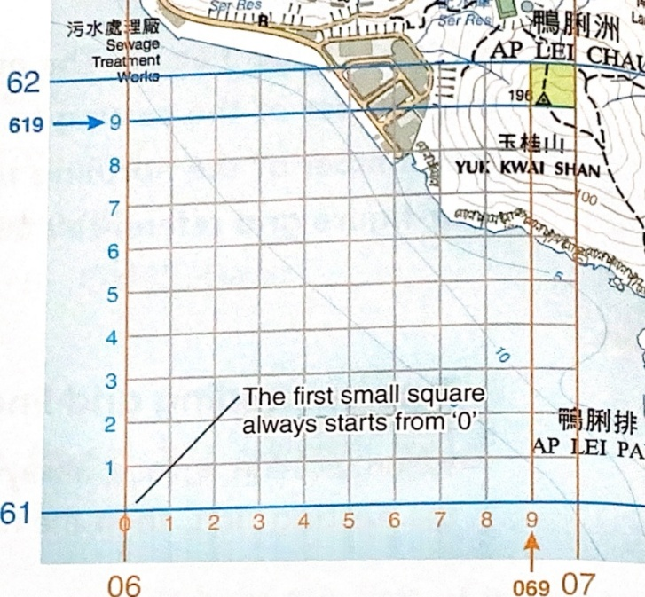
E.g. for the trigonometric station, it is on 069619
Just use a ruler to measure
X axis

Large/small-scale map
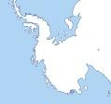  1:1000 | 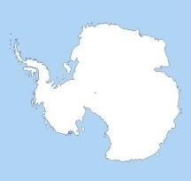  1:5000
large-scale map | small-scale map
shows a smaller actual area | shows a larger actual area
more detail | less detail
How to compare r.f.
1:1000=¹⁄₁₀₀₀
1:5000=¹⁄₅₀₀₀

Because¹⁄₁₀₀₀>¹⁄₅₀₀₀
So 1:1000 is a larger scale map

Converting scale
Representative fraction(1:20000)
Statement scale(1cm to 200m)
Linear scale

Direction

Compass point
8-point compass point
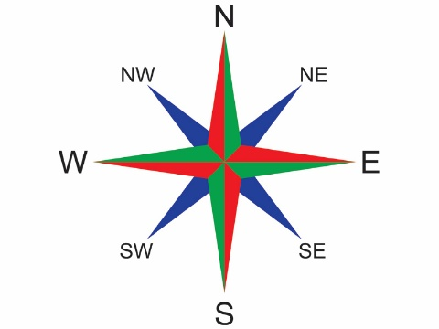

Whole circle bearing
Measured clockwise from the north

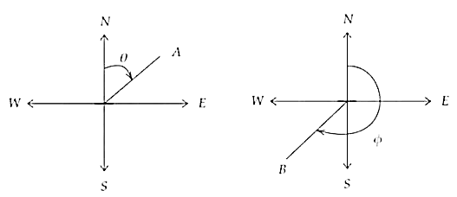

Reduced bearing
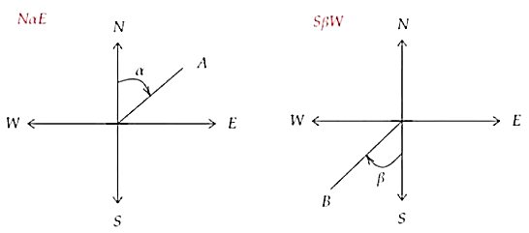
- Wouldn’t exceed 90°
- E.g. N45°E

Latitude and longitudes
- On east west directions
- Equator = 0°
- North Northen hemisphere
- South Southern hemisphere
- 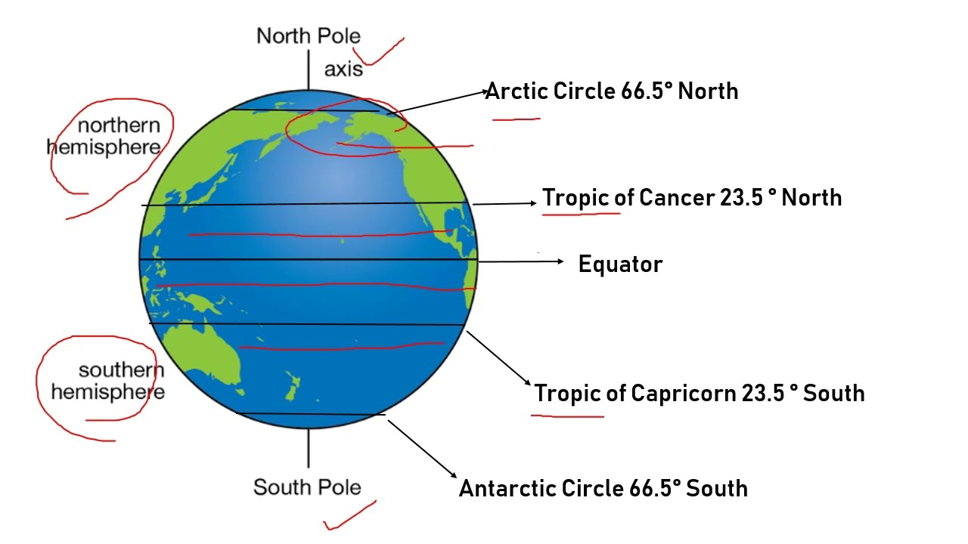

Longitudes
- Run from North pole to south pole
- 0°=prime meridian = passing through London
- To east=eastern hemisphere
- To west = western hemisphere
- 180°W, 180°S = International date line

